1. The ping utility is used to test the reachability of a host on an IP network. It sends ICMP Echo Request messages to the target and waits for a reply, allowing you to measure the round-trip time and determine packet loss.
2. The basic syntax for ping in Windows is:

ping [options] target_host

example : ping [www.google.com](http://www.google.com)

To test connectivity to a local host

Run.. ping 127.0.0.1 in terminal.

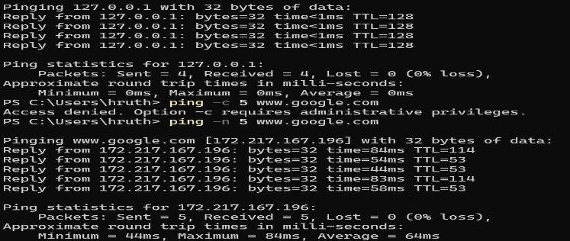

1. The -n option specifies the number of ICMP Echo Request packets to send.

The -l option sets the size of the ICMP Echo Request packet in bytes.

The -i option sets the TTL value for the packet.

The -w option sets a timeout in milliseconds to wait for each reply.

For reference see the diagram below

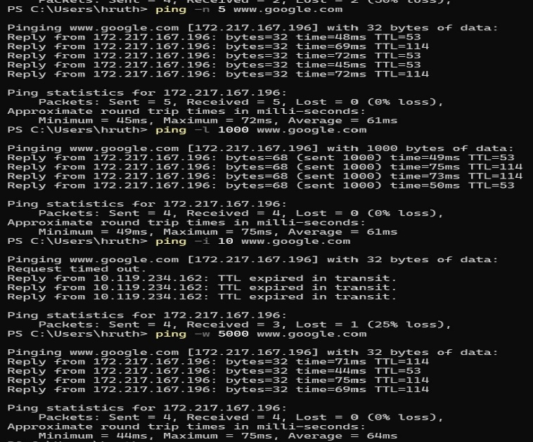

4. A user reports intermittent connectivity issues with a remote server. The connection drops frequently, causing disruptions in accessing resources hosted on the server.

Check Connectivity like ping [www.server.com](http://www.server.com)

Check for Packet Loss , ping -n 100 [www.server.com](http://www.server.com)

Extend the timeout to 2 seconds to catch high latency responses. Using ping -n 100 -w 2000 [www.server.com](http://www.server.com)

A Low TTL might indicate Routing issues. Use -I option to adjust

Test with large Packet size using -l so we can check whether network handles loads properly or not.

For 5.1, 5.2, 5.3, 5.4 The codes are in github page and images are below

